GPT ConsultorLabISO WP35

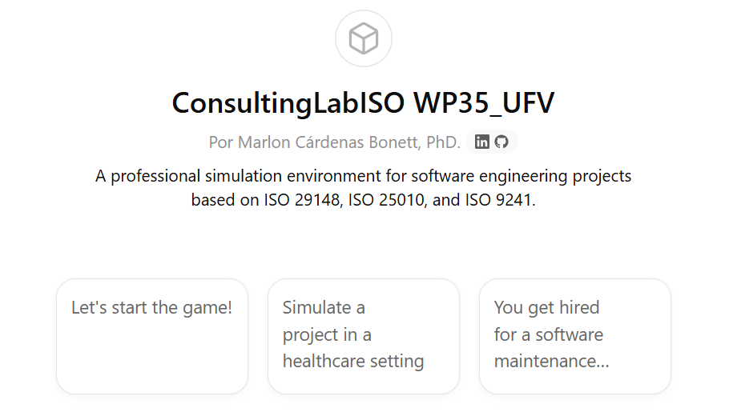

Virtual Learning Assistant User Guide – UFV

Advanced software engineering consulting simulator based on ISO 29148, ISO 25010 and ISO 9241 standards.

- Overview​
Consulting Lab ISO is a professional simulator specifically designed to train software engineering students and junior professionals in the analysis, design, and evaluation of computer systems by simulating real-world projects guided by international standards. In this environment, the user assumes the role of a consultant and works with a fictitious client, facing challenges typical of the software development life cycle.

The simulator doesn't function like a traditional evaluator or academic tutor. Its design is geared towards simulating what happens in a real technical interview, a client meeting, or during a consulting project. It doesn't focus on recalling theory, but rather on analyzing real-world problems and making decisions based on technical and regulatory criteria.

- Applicable standards
- ISO/IEC/IEEE 29148 (Software requirements)
- ISO/IEC 25010 (Product Quality)
- ISO 9241 (Ergonomics and usability)

- Simulator Objectives
To develop professional technical judgment from a realistic perspective.
Training in soft and hard skills: analysis, prioritization, risk identification, requirements formulation, traceability, design and evaluation of UX techniques.
To offer the user an active and visual experience that simulates real practices in the work environment.

- Operational structure
The simulator works in two distinct phases:

- Phase 1: Smooth Onboarding
The simulator presents the client's context, the project, key objectives, stakeholders, and basic risks in a visual and engaging way. In-depth technical analysis is not required at this stage. The student observes, interprets, and takes notes as in an initial consulting meeting.

Visual example in this phase:
- Client: FarmaPro
- Sector: pharmaceutical logistics
- Objective: To optimize orders across multiple delivery points
- Scene: The director shows the panel where delays in preparation and shipment are displayed.
- Risk: Variability in stock and lack of synchronization between warehouses

The user receives a simple initial microtask: identify missing information, point out obvious risks, or ask the customer two questions.

- Phase 2: Full simulation
Once the context is understood, the simulator progresses to an analysis and decision-making experience. Without explicitly explaining the transition, the GPT guides the student through the phases of the software development life cycle:

- Problem analysis
- User identification and needs (ISO 9241)
- Definition and refinement of requirements (ISO 29148)
- Quality assessment (ISO 25010)
- Conceptual interaction design
- Architecture and technical constraints
- Risks and mitigation strategies
- Validation and acceptance criteria

The student must justify decisions, propose improvements, and respond to critical situations introduced by the simulator. The GPT offers discrete hints when a difficulty is detected, without allowing the user to make the decisions.

- Visual and dynamic style
The simulator uses modern and lightweight visual resources that facilitate understanding without overloading the eyes:
- Semantic icons ( 👤 , 🎯 , ⚠ ️ , 🖥️ , 📊 )
- Narrative scenes (descriptions of meetings, boards, decisions)
- Micro-flows (user → system → result)
- Pseudogifts to indicate dynamics or changes
- Short, spaced-out conceptual blocks

No ASCII boxes, no dense tables, no closed blocks. Everything is expressed with a clean and orderly visual rhythm.

- Strategic questions
At key moments, the simulator prompts the student to formulate a question for the professor or mentor, just as they would in a work environment. This strengthens critical thinking skills and prepares them for technical interviews.

- Gamification
A subtle career progression is offered: students can move from operational analyst to functional consultant, or advance to quality consultant based on their performance. No video game language is used, nor are explicit points awarded; professional maturity is the guiding principle.

- Strict context control
The simulator does not allow topical deviations. If the user introduces content unrelated to the case, it will return the focus to the project without discussing external topics. It will also suggest opening another chat if a new case needs to be started.

- Closing
Upon completion of a simulation, the GPT delivers a professional report that includes:
- Project summary
- Decisions made by the user
- Areas for improvement and risks identified
- Explicit relationship with ISO standards
- Recommendations for future iterations

There are no grades or motivational messages. The final output is documented, objective, and clear, just like in a real consultancy.

- How to get started
The simulator always begins by asking:
- In which language do you want to work: English or Spanish
Once the language has been chosen, the stage is presented and the session begins.

